**PHASE 2** : INNOVATION

**DOMAIN NAME :** CLOUD APPLICATION DEVELOPMENT

**PROJECT NAME** : MACHINE LEARNING MODEL DEPLOYMENT WITH IBM

CLOUD WATSON STUDIO

**SYSTEM ARCHITECTURE :**

The system design encompasses a cloud-native architecture that leverages IBM Cloud infrastructure. It utilizes scalable computing resources, storage, and networking components to handle the demands of machine learning model deployment and achieve high availability and fault tolerance.

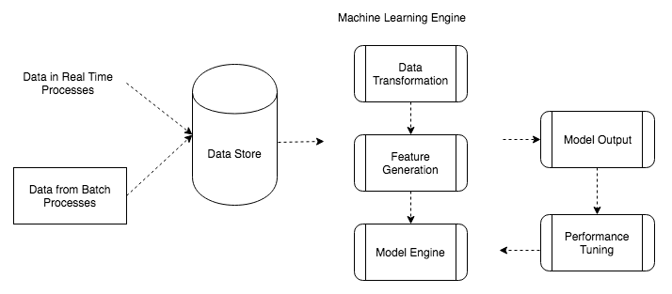

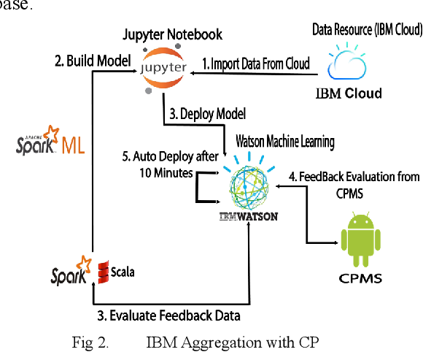

**PROBLEM STATEMENT :**

In the healthcare industry, there is a growing need to deploy machine learning models to enhance patient care, streamline operations, and improve outcomes. However, deploying machine learning models in healthcare comes with several challenges:

**1. Data Privacy and Security**: Patient data is highly sensitive, and ensuring privacy and security while deploying machine learning models is crucial. Compliance with regulations like HIPAA (Health Insurance Portability and Accountability Act) is mandatory.

2**. Model Explainability**: Healthcare professionals need to understand how and why a model makes predictions. Ensuring model transparency and interpretability is essential for gaining trust.

**3. Integration with Existing Systems**: Healthcare organizations often have legacy systems and EMR (Electronic Medical Records) systems. Integrating machine learning models seamlessly with these existing systems can be challenging.

4. **Real-time Predictions**: In healthcare, real-time predictions are often required, especially in critical situations like patient monitoring. Ensuring low-latency model predictions is essential.

**SOLUTION:**

Deploying machine learning models in healthcare using IBM Cloud Watson Studio can address these challenges:

**1. Data Privacy and Security:**

Use IBM Cloud's robust security features, including encryption, access controls, and audit logs. Ensure compliance with healthcare data protection regulations.

**2. Model Explainability:**

Employ interpretable machine learning techniques and algorithms. Utilize Watson OpenScale for monitoring and explanation of model predictions.

**3. Data Quality :**  Implement data preprocessing and cleansing pipelines to improve data quality. Use automated data quality tools available in Watson Studio.

**4. Integration with Existing Systems:**

Leverage Watson Studio's ability to integrate with various data sources and legacy system.Use APIs to make predictions available within existing applications and EMR systems.

**5. Real-time Predictions:**

Deploy models as RESTful APIs using Watson Machine Learning for low-latency predictions. Utilize Watson Studio's real-time scoring capabilities for immediate feedback.

By using IBM Cloud Watson Studio and its associated services, healthcare organizations can efficiently address these challenges and deploy machine learning models that enhance patient care, automate administrative tasks, and provide valuable insights for clinical decision making, all while ensuring data privacy and compliance with healthcare regulations.

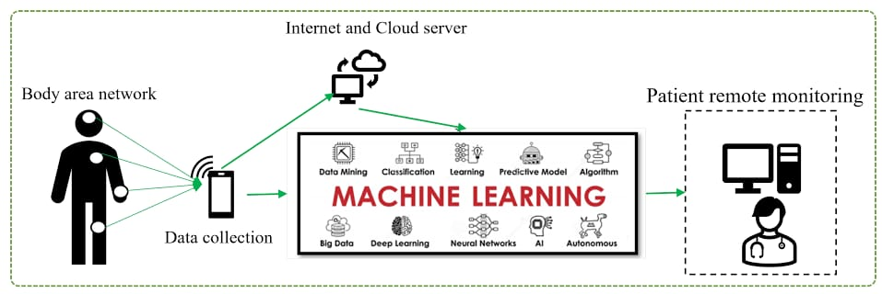

# **STEPS TAKEN :**

### **Step 1: Project Setup**

We began by setting up the project in IBM Cloud Watson Studio, creating a workspace and importing our design files.

### **Step 2: Data Preparation**

We carefully prepared and preprocessed the data to ensure its quality and suitability for the machine learning model.

### **Step 3: Model Development**

Using Watson Studio's powerful tools and libraries, we developed our machine learning model based on the design and data.

**MODULES AND ALGORITHM THAT ARE USED ON INTEGRATING MACHINE LEARNING MODEL DEPLOYMENT USING IBM CLOUD WATSON STUDIO:**

**1. APACHE SPARK WITH SCALA:**

**Apache Spark** : Use Spark's distributed computing capabilities for handling large healthcare datasets and performing distributed machine learning tasks.

**Scala:** Scala is a preferred language for Spark, as it offers functional programming capabilities and seamless integration with Spark.

**2. DATA PREPROCESSING MODULES IN SPARK AND SCALA:\*\***

**Spark DataFrame API** : Used for data loading, cleaning, and transformation.

**MLlib** : Spark's machine learning library provides various data preprocessing methods.

**Scala Collections** : Utilize native Scala collections for data manipulation and preparation.

**Machine Learning Algorithms in Spark and Scala:**

**Spark MLlib :** Provides a wide range of machine learning algorithms for classification, regression, clustering, and recommendation tasks. Some popular algorithms include:

- Logistic Regression

- Random Forest

- Gradient-Boosted Trees (GBT)

- Decision Trees

- Support Vector Machines (SVM)

- k-Means Clustering

- Naive Bayes

**Custom Scala ML Libraries** : You can create custom implementations of machine learning algorithms using Scala, especially if specific algorithms are required for healthcare applications.

**Model Deployment and Integration:**

**IBM Watson Machine Learning**: Deploy Spark/Scala models as RESTful APIs within IBM Cloud Watson Studio.

**Scalatra** : Use Scala-based web frameworks for building custom APIs.

**Jupyter Notebooks**: Create and document deployment workflows using Scala code within Jupyter notebooks.

**Data Storage and Management:**

**IBM Cloud Object Storage**: Store and manage large healthcare datasets.

**IBM Db2 or other databases:** For structured healthcare data storage and management.

It's important to consider that deploying machine learning models in healthcare involves additional complexities, such as compliance with healthcare data regulations ethical considerations, and informed consent. Additionally, patient data privacy and security are paramount. Careful handling of sensitive data and adherence to best practices in healthcare data management are essential.